Blue-Action Kick Off

Date
From 13:00 Wednesday 18 January 2017 till noon Friday 20 January 2017

Venue
Harnack-Haus, Ihnestrasse 16-20, 14195 Berlin (http://www.harnackhaus-berlin.mpg.de/)
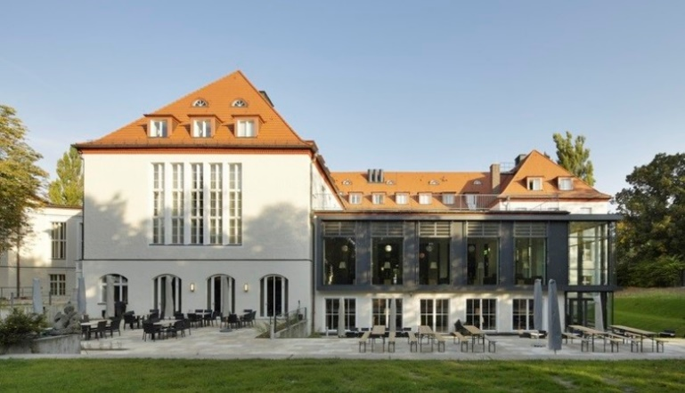

How to reach Harnack Haus (district Dahlem)
- Getting there from Tegel airport: check the Journey planner http://www.bvg.de/en/ (approx. 45 minutes). Metro ticket costs 2,70 Euro. Please remember to validate your ticket before starting your journey!
- Getting there from Schoenefeld airport: check the Journey planner http://www.bvg.de/en/ (approx. time is 75 minutes. Metro ticket costs 3,30 Euro. Please remember to validate your ticket before starting your journey! An easy way is to take bus X7 from the airport to the Metro station “Rudow” and then take the Metro line U7 to get closer to the city center.
- Closest metro station: Thielplatz (U3 line), marked with a U on the map below. Within the city, ne single ticket for the metro costs 2,70 Euro. Please remember to validate your ticket before starting your journey!
- Taxi: +4930202020 or +4930261026

Map of the location
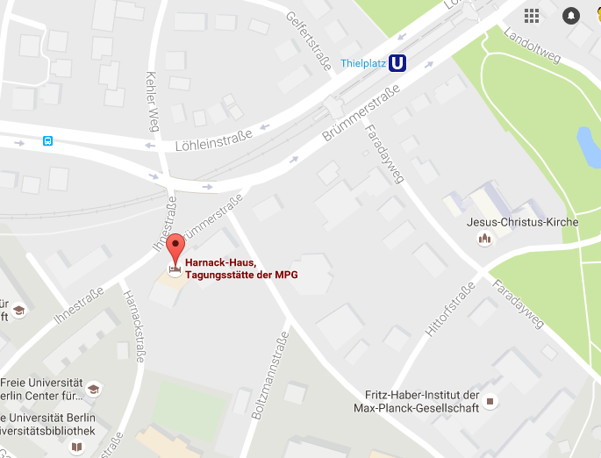

Hotels recommended
We could not have a block reservation for the hotels below.
The following list is just a suggestion for you, most of the hotels are within walking reach from the venue.
Please book your hotel directly.
- Seminaris CampusHotel Berlin http://www.seminaris.de/hotels/seminaris-campushotel-berlin.html
- Hotel Eckstein hoteleckstein.de
- Novum hotel Ravenna Steglitz http://novum-hotel-ravenna-berlin-steglitz.hotel-in-berlin.org/de/
- Best Western Plus Hotel Steglitz si-hotel.com
- In Hotel inhotelberlin.de
- Hotel Pension Dahlem hotel-dahlem.de
- Hotel Pension Enzian hotel-pension-enzian.de
- Apartment-Hotel-Dahlem apartment-hotel-berlin.de

Block reservation at Harnack Haus Guesthouse
We have a call-in allotment at Harnack Haus guest house: There are app. 48 rooms available. First come first served.
Please book your accommodation directly, and pay at the hotel upon arrival. The accommodation prices are 70-76 Euro with breakfast for single rooms and 104/109 Euro for the double ones.
How to make a reservation?
Send a mail to info@harnackhaus-berlin.mpg.de
Mention the booking code for hotel accommodation is MPI 3017
Put the project office in cc in your mail: chiara.bearzotti@gmail.com & smo@dmi.dk
Booking deadline is Monday 19 December 2016.

